Pranav Maroli

ME147

2/14/2017

Project Proposal

**a) Sample GUI**

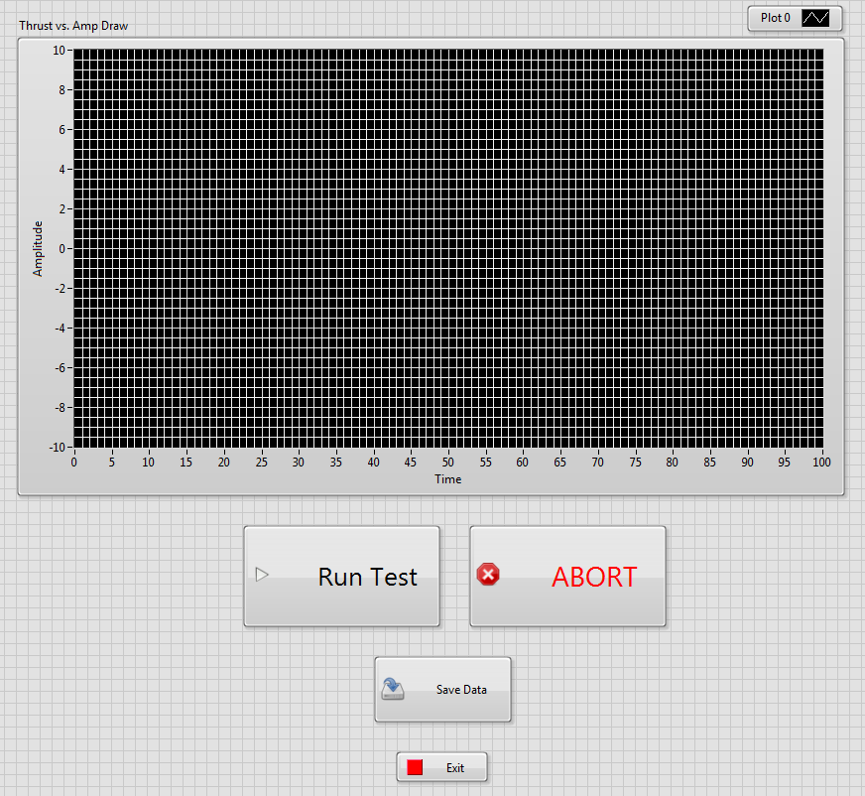

**b) Sample Save File Format**

The files would be saved in an excel sheet with columns of throttle percentage (%), thrust (g), and current draw (A) as shown below:

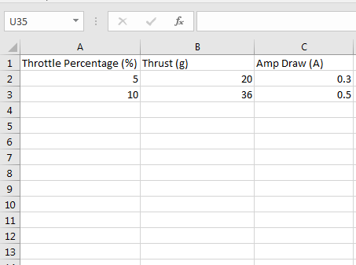

**c) Simple Project Description**

Using a variety of different propellor sizes and pitches, plots of thrust vs. amp draw of one specific motor are to be created. This project would be successful if, when all of the code is written, a user can attach a propellor to the motor, press run, get a clean plot of the data, and then load multiple other sized propellers and repeat the process.

The major challenge, apart from setting up a fixture to mount a force gauge to measure the thrust force, would be finding a way to input a Pulse Width Modulation (PWM) signal into the speed controller for the motor. The speed controller is meant to be used with an RC transmitter and receiver that use a PWM signal; in absence of the TX/RX system, a PWM signal must be fed directly into the speed controller. While running these tests manually, we used a weight scale to measure the thrust force, but unless there is a way to extract readings directly from a scale of that type, a force gauge or some other lab force measurement device must be used.

**d) Software/Hardware Requirements**

To do this project, I would need a computer with LabVIEW inside of the design lab and a DAQ card. I’m not quite sure how to generate a PWM signal yet, but I may need some extra equipment to do that.